P a g e | 1

#### Internship Project Report

#### On

#### Object Detection in Underwater Images



**Under the supervision of**

#### Dr. Rajib Ghosh

#### Assistant Professor (Grade-1)

#### Department of Computer Science and Engineering

#### National Institution of Technology Patna – 800005

**Submitted by:**

**Rahul Kumar Chaudhary**

Registration No- 2021ITB074

B Tech 6th Semester

Indian Institute of Engineering Science and Technology, Shibpur

Internship Duration: 04.06.2024 – 19.07.2024

**CERTIFICATE**

Department of Computer Science and Technology

National Institute Of Technology Patna



#### This is to certify that the “Internship Project Report” submitted by Rahul Kumar Chaudhary, Registration No.: 2021ITB074, a B. Tech Student of Indian Institute of Engineering Science and Technology, Shibpur, under the supervision of Dr. Rajib Ghosh, Assistant Professor (Grade-1) in the Department of Computer Science and Engineering at the National Institute of Technology Patna, has completed all other requirements for submission of the project. I hereby recommend the acceptance of the project entitled “Object Detection In Underwater Images” in the partial fulfillment of the requirements for the award of B. Tech degree.

___________________

Supervisor

**Dr. Rajib Ghosh**

Assistant Professor (Grade-1)

Computer Science and Engineering Department

National Institute of Technology, Patna

04st June to 19th July (2024)



## DECLARATION

I, the students of the 6th semester, hereby declare that this project entitled **“**Object Detection in Underwater Images**”** has been carried out by me in the Department of Computer Science and Engineering of the National Institute of Technology Patna under the guidance of Dr. Rajib Ghosh, Assistant Professor (Grade-1) of Computer Science and Engineering, NIT Patna. No part of this project has been submitted for the award of the degree or diploma to any other Institute.

Rahul Kumar Chaudhary

Registration No-2021ITB074



## ACKNOWLEDGEMENT

I take this opportunity to express my profound gratitude and deep regards to Dr. Rajib Ghosh for her exemplary guidance, monitoring, and constant encouragement throughout the course of this project.

I also extend my heartfelt thanks to the entire CSE department of NIT Patna for providing the necessary technical facilities and environment that supported me in performing to the best of my potential. The motivation I gained from this project will go a long way in learning and leveraging these technologies further and incorporating them into my future project work. I am extremely humbled and grateful for the opportunity and exposure provided to me in computer vision and machine learning through this project.

Rahul Kumar Chaudhary

Registration No -2021ITB074

**TABLE OF CONTENT**

|  |  |  |
| --- | --- | --- |
| Sl No | Topics | Page No |
| 1 | Chapter 1  Abstract | 5 |
| 2 | Chapter 2  Introduction  2.1 Background  2.2 Objectives | 6 |
| 3 | Chapter 3  Literature Survey | 8 |
| 4 | Chapter 4  Datasets Description  4.1 UTDAC2020 dataset  4.2 URPC2020 dataset | 10 |
| 5 | Chapter 5  My Proposed Method  5.1 Image Enhancement  5.2 Object Detection  5.2.1 Faster RCNN Resnet 50  5.2.2 Yolo v8 | 12 |
| 6 | Chapter 6  Experiment Result and Discussion  6.1 Tools  6.2 Evaluation Metrics  6.1 Qualitative Result  6.2 Quantitative Result | 16 |
| 7 | Chapter 7  Conclusion | 22 |
| 8 | Chapter 8  References | 23 |

**Chapter -1**

# ABSTRACT

Object detection in underwater images presents unique challenges due to the complex environment, poor visibility, and varying lighting conditions. This report explores advanced object detection techniques applied to underwater imagery, focusing on the use of deep learning models and image enhancement methods. Three datasets, UTDAC2020 and URPC2020, were utilized to train and evaluate the performance of the Faster R-CNN and YOLO models. Image enhancement techniques were applied prior to detection to improve the visibility and contrast of underwater images. The models were trained and fine-tuned with various hyperparameters, achieving a mean Average Precision (mAP) of 74.29% and 75.29% respectively,with Faster R-CNN using the ResNet-50 backbone. This study demonstrates the potential and limitations of current object detection models in underwater environments and highlights the importance of image preprocessing in improving detection accuracy.

# Chapter 2

# INTRODUCTION

### 2.1 Background

Underwater environments present a unique set of challenges for object detection tasks due to the physical properties of water and the nature of underwater scenes. This section provides an overview of these challenges and the importance of underwater object detection.

#### Challenges in Underwater Object Detection

1. **Light Absorption and Scattering**:
   * **Absorption**: Water absorbs light, especially in the red and yellow wavelengths, leading to a dominance of blue and green hues in underwater images. This absorption results in poor visibility and loss of color information, which can complicate the detection of objects.
   * **Scattering**: Light scattering caused by water particles (like plankton and sediment) can blur images and reduce their contrast, making it difficult to distinguish objects from their backgrounds.
2. **Noise and Distortion**:
   * **Backscatter**: The reflection of light particles off water particles back into the camera causes backscatter, which appears as noise in the image.
   * **Distortion**: The refraction of light when transitioning from water to the camera lens can cause geometric distortions in the captured images.
3. **Variability in Appearance**:
   * **Object Variability**: Underwater objects can vary greatly in size, shape, color, and texture, making it difficult to develop models that generalize well across different types of objects.
   * **Environmental Conditions**: Changes in water clarity, lighting conditions, and the presence of marine growth on objects can alter the appearance of objects, further complicating detection.

#### Advances in Object Detection Techniques

1. **Machine Learning and Deep Learning**:
   * **Traditional Methods**: Early underwater object detection methods relied on handcrafted features and conventional machine learning algorithms, which often struggled with the complex underwater environment.
   * **Deep Learning**: Recent advances in deep learning have revolutionized object detection, with convolutional neural networks (CNNs) and region-based CNNs (R-CNNs) achieving state-of-the-art performance. These models automatically learn hierarchical features from data, making them more robust to the variability in underwater images.
2. **Image Enhancement Techniques**:
   * **Preprocessing**: Techniques such as histogram equalization, contrast enhancement, and dehazing are used to preprocess underwater images, improving their quality before feeding them into detection models.
   * **End-to-End Models**: Some modern approaches integrate image enhancement directly into the object detection pipeline, allowing the model to learn optimal enhancements during training.

In this study, we explore the use of advanced object detection models, specifically Faster R-CNN and YOLO, in the context of underwater environments. We also investigate the effectiveness of image enhancement techniques in improving detection accuracy. By conducting experiments on three diverse underwater datasets—UTDAC2020, URPC2020, and RUOD—we aim to identify the best practices for underwater object detection and contribute to the broader understanding of this challenging but essential field.

#### 2.2 Objectives

The primary objective of this study is to enhance the accuracy and efficiency of underwater object detection by leveraging advanced machine learning models and image enhancement techniques. Specifically, this report aims to:

1. Evaluate the performance of state-of-the-art object detection models, including Faster R-CNN and YOLO, on underwater datasets.
2. Investigate the impact of image enhancement techniques on the detection performance.
3. Compare the results across two different underwater datasets: UTDAC2020 and URPC2020
4. Identify the best-performing models and configurations for underwater object detection.

# Chapter 3

# LITERATURE SURVEY

#### In the paper Ref. [1], The researches proposed method a weighted multi-error information entropy-based YOLO (You Only Look Once) network is proposed to address underwater illumination noise affecting the detection accuracy. First, underwater illumination is essentially structural and non-uniform, and it is modeled as an independent and piecewise identical distribution, which is a generic noise model to describe the complex underwater illuminating environment and accommodates the traditional Gaussian distribution as a special case. Second, assisted by the proposed illumination noise model, a minimum weighted error entropy criterion, which is an information-theoretic learning method, is introduced into the loss function of YOLO network, and then the network parameters are trained and optimized to improve the detection performance. Furthermore, a multi-error processing strategy is simultaneously used to handle vector errors during information back-propagation in order to accelerate convergence. Experiments on under water object detection datasets including URPC2018, URPC2019 and Enhanced dataset, show the proposed weighted multi-error information entropy based YOLOv8 network gets mean average precision (MAP) of 88.7%, 91.8% and 96.7% respectively.

#### 

#### In the paper Ref. [2], This work proposes a path-augmented Transformer detection framework to address these limitations to explore the semantic details of small-scale underwater targets in complex environments. Experimental results on open-source underwater and remote sensing images of UTDAC, RUOD, and ADios show that the proposed method outperforms other underwater object detection methods in terms of precision(P), recall(R), comprehensive evaluation index of F1-score are (0.8387, 0.9148, 0.8751), (0.8795, 0.9360, 0.9069) and (0.8257, 0.8953, 0.8591) respectively.

#### 

#### In the paper Ref. [3] we propose a Gated Cross-domain Collaborative Network (GCC-Net) to address the challenges of poor visibility and low contrast in underwater environments, which comprises three dedicated components. Firstly, a real-time UIE method is employed to generate enhanced images, which can improve the visibility of objects in low-contrast areas. Secondly, a cross-domain feature interaction module is introduced to facilitate the interaction and mine complementary information between raw and enhanced image features. Thirdly, to prevent the contamination of unreliable generated results, a gated feature fusion module is proposed to adaptively control the fusion ratio of cross-domain information. Our method presents a new UOD paradigm from the perspective of cross-domain information interaction and fusion. Experiments on under water object detection datasets including Brackish, Trashcans and WPBB, show the proposed weighted multi-error information entropy based GCC-network gets mean average precision (MAP) of 98.3%, 61.2% and 99.5% respectively.

#### In the Ref. [4] This paper proposed a method for underwater image enhancement based on the fusion method is capable of accurately restoring underwater images. The proposed work takes a single image as input, and a sequence of operations such as white balancing, gamma correction, sharpening, and manipulating weight maps are performed on the input image. Finally, multiscale image fusion of the inputs is done to obtain the resultant output. In the initial stage, the colour-distorted input image is white balanced to remove the colour casts, maintaining a realistic subsea image. In the second stage, CLAHE (Contrast Limited Adaptive Histogram Equalization) is performed on the gamma-corrected image. CLAHE plays a significant role in the luminance enhancement of underwater images. At the same time, histogram equalization is performed on the sharpened image. The weight maps analyse image characteristics that properly specify the spatial pixel relationship. Finally, in the last stage, multiscale pyramidal fusion of the inputs and weight maps is performed. The fusion performed here is the Pyramidal fusion. Result analysis depicts the improvement of the underwater images using the proposed method.

**Chapter 4**

# DATASETS DESCRIPTION

**4.1 UTDAC2020 Dataset**

The UTDAC2020 dataset is a collection of images and annotations used for object detection tasks, particularly focusing on underwater scenes. UTDAC stands for Underwater Trash Detection and Classification, and the dataset is designed to help researchers develop and evaluate models for detecting and classifying underwater trash. It typically includes a variety of images taken in underwater environments, annotated with bounding boxes and labels to identify different types of trash and other objects of interest.

This dataset is valuable for training object detection models, such as Faster R-CNN, and includes several key components:

1. **Train and Validation Images**: Separate folders containing images for training (5168) and validation (1293).
2. **Annotations**: Annotation files that provide the ground truth bounding boxes and class labels for the objects in the images. These annotations are often in formats such as COCO JSON.
3. **Classes**: The classes or categories of objects in the dataset, which typically include various: Echinus, Starfish, Holothurian, Scallop, Waterweeds.

The UTDAC2020 dataset is commonly used in research and competitions to advance the development of algorithms for underwater image analysis and environmental monitoring.

**4.2 URPC2020 Dataset**

The URPC2020 dataset is a collection of underwater images used for object detection and segmentation tasks, particularly focused on the detection and classification of underwater objects. URPC stands for Underwater Robot Picking Contest, which is an event that encourages the development of technologies for underwater object detection and robotic picking. The dataset is specifically designed to support research and development in underwater computer vision.

1. **Train and Validation Images**: Separate folders containing images for training (4361) and validation (1094).
2. **Annotations**: Annotation files that provide the ground truth bounding boxes and class labels for the objects in the images. These annotations are often in formats such as COCO JSON.
3. **Classes**: The classes or categories of objects in the dataset, which typically include various: Echinus, Starfish, Holothurian, Scallop.

The URPC2020 dataset is valuable for advancing underwater robotics, environmental monitoring, and marine biology research, contributing to the development of robust underwater vision systems.

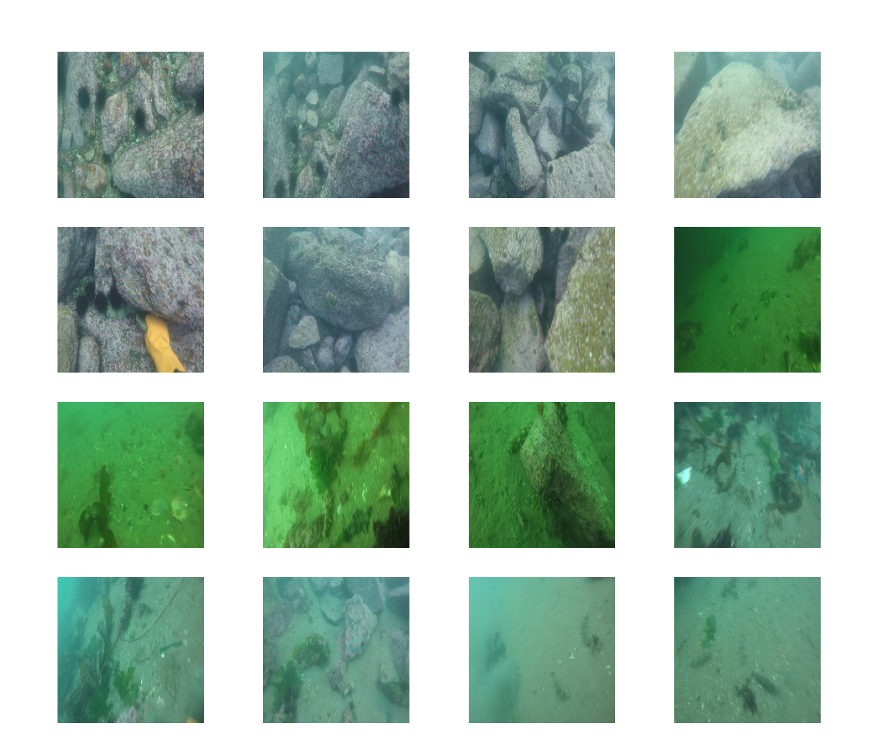

**Fig1: Some Images of the Datasets**

# Chapter 5

# MY PROPOSED METHOD

In this section, we describe the methodology employed to enhance and detect objects in underwater images. Our approach involves two main stages: image enhancement and object detection. We utilize two state-of-the-art object detection models, Faster R-CNN ResNet-50 and YOLOv8, to achieve high accuracy in detecting underwater objects.

**5.1 Image Enhancement**

Underwater images often suffer from issues such as low contrast, color distortion, and poor visibility due to light scattering and absorption in the water. To address these challenges, we employ an image enhancement technique to improve the quality of the images before feeding them into the object detection models.

#### Challenges in Underwater Imaging

1. **Color Distortion:** Water absorbs and scatters light, particularly affecting the red wavelength, which leads to images with a bluish or greenish tint.
2. **Low Contrast:** The scattering of light reduces the contrast of underwater images, making it difficult to distinguish objects.
3. **Poor Visibility:** Particles in water further degrade image quality by causing haziness and blurring

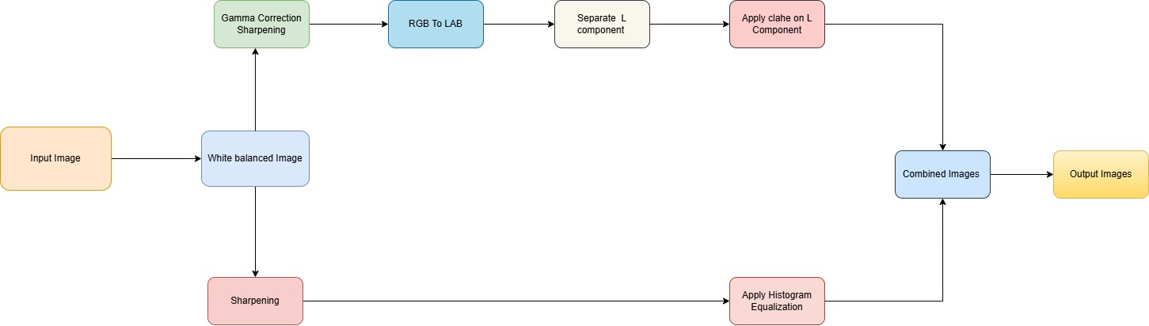

Fig1: Work flow Diagram of Image Enhancement

# My Image enhancement process is as follows:

1. Input Image to White Balanced Image:

* The input image is processed to remove color casts and achieve a realistic subsea appearance using white balancing techniques.

2. White Balanced Image to Gamma Corrected Image:

* Gamma correction is applied to the white balanced image to adjust the brightness and contrast.

3. White Balanced Image to Sharpened Image:

* The white balanced image is sharpened to enhance the edges and details.

4. Gamma Corrected Image to RGB to LAB Conversion:

* The gamma corrected image is converted from RGB color space to LAB color space to separate luminance and chrominance information.

5. Separate L Component:

* The L (luminance) component is separated from the LAB image for further processing.

6. Apply CLAHE on L Component:

* Contrast Limited Adaptive Histogram Equalization (CLAHE) is applied to the L component to enhance the luminance and improve the visibility of underwater features.

7. Sharpening Image to Apply Histogram Equalization:

* Histogram equalization is applied to the sharpened image to enhance its overall contrast.

8. Combine Weighted Outputs:

* The weights from the histogram equalized image and the CLAHE-applied L component are combined to produce the final enhanced image.

**5.2 Object Detection**

Two state-of-the-art object detection models are used in this project: Faster R-CNN with ResNet-50 backbone and YOLOv8. These models are chosen for their accuracy and efficiency in detecting objects in challenging underwater environments.

**5.2.1 Faster R-CNN with Resnet 50**

**Faster R-CNN** (Region-based Convolutional Neural Networks) is an advanced object detection framework that builds upon the original R-CNN and Fast R-CNN algorithms. It introduces a Region Proposal Network (RPN) that shares full-image convolutional features with the detection network, enabling nearly cost-free region proposals. The framework is known for its high accuracy and efficiency in detecting objects within images.

#### Key Components:

1. **Convolutional Backbone (ResNet-50):**
   * The backbone network is used to extract features from the input image.
   * ResNet-50 is a popular convolutional neural network architecture known for its deep layers (50 layers) and residual learning capabilities, which help in training very deep networks by mitigating the vanishing gradient problem.
2. **Region Proposal Network (RPN):**
   * The RPN generates a set of candidate object proposals (regions) from the feature maps produced by the backbone network.
   * It uses a small network with convolutional layers to slide over the feature map and propose regions of interest (RoIs) by predicting objectness scores and bounding box coordinates.
3. **RoI Pooling:**
   * The regions proposed by the RPN are fed into an RoI pooling layer that extracts fixed-size feature maps for each region.
   * This is done to ensure that the subsequent fully connected layers can process these regions regardless of their original size.
4. **Region-based Classification and Regression:**
   * The fixed-size feature maps are passed through fully connected layers to classify the objects within each region and refine their bounding box coordinates.
   * 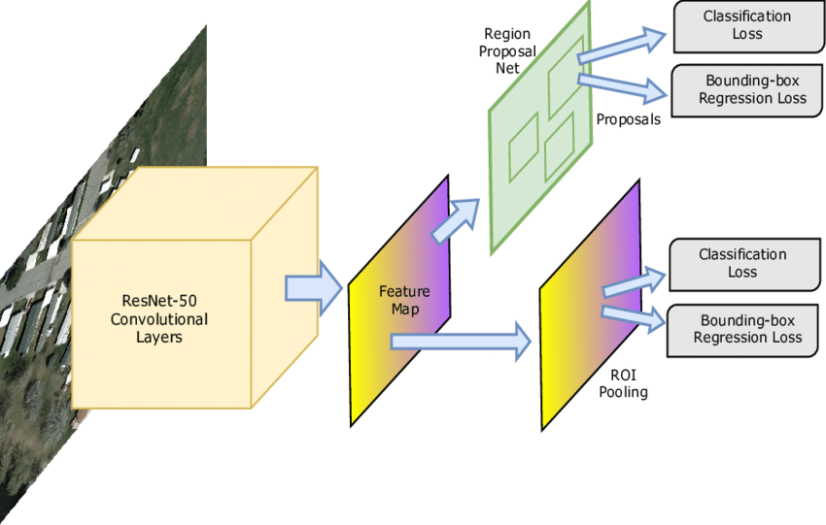The classification layer predicts the probability of each class, while the regression layer adjusts the bounding box coordinates for better localization.

Fig 2: Faster RCNN Resnet 50 Model Architecture

# 5.2.2 Yolo v8

YOLOv8 (You Only Look Once, version 8) is the latest iteration of the YOLO (You Only Look Once) series, a family of single-stage object detection models. YOLO models are known for their speed and efficiency, capable of achieving real-time object detection. YOLOv8 continues this legacy by incorporating new techniques and improvements to enhance performance in terms of both accuracy and speed.

### Key Features of YOLOv8

1. **Enhanced Backbone:**
   * YOLOv8 uses a more efficient and powerful backbone network for feature extraction. The backbone is designed to capture high-level features from the input images with improved accuracy and efficiency.
2. **Improved Neck and Head:**
   * The neck and head of YOLOv8 are designed to aggregate features from different scales, which helps in detecting objects of various sizes more effectively. The improved design enhances the model's ability to make accurate predictions.
3. **Anchor-Free Detection:**
   * YOLOv8 may incorporate anchor-free detection, eliminating the need for predefined anchor boxes. This simplifies the detection process and can lead to improved accuracy and faster inference times.
4. **Better Training Techniques:**
   * YOLOv8 leverages advanced training techniques such as label smoothing, data augmentation, and new loss functions. These techniques help in making the model more robust and improving its generalization capabilities.
5. **Post-Processing Enhancements:**
   * Improved post-processing techniques like Non-Maximum Suppression (NMS) and Soft-NMS help in refining the final detections, reducing false positives, and ensuring accurate object localization.

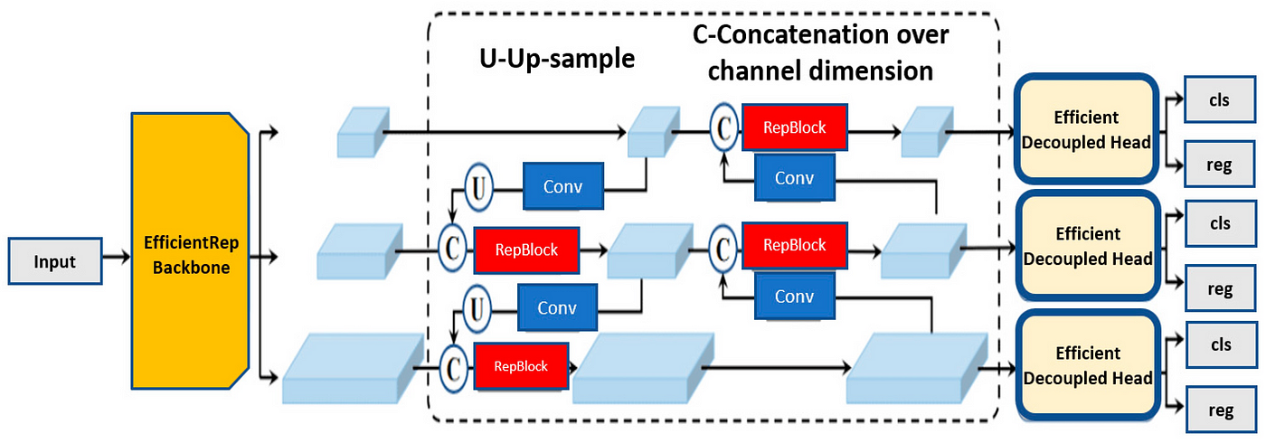

# Fig3: Yolo v8 Model Architecture

#### Chapter 6

#### EXPERIMENT RESULT AND DISCUSSION

**6.1 TOOLS:** Google colab, draw.io, Python, Libraries: NumPy, Pandas, Seaborn /Matplotlib, Open CV,

Pytorch, and Torchvision

**6.2 Evaluation Metrics**

Mean Average Precision (mAP) is a performance metric used to evaluate object detection algorithms. It is a comprehensive measure that combines both precision and recall across different classes and various threshold levels for Intersection over Union (IoU). Here's a detailed explanation of how mAP is calculated:

### Key Concepts:

1. **Precision and Recall**:
   * **Precision** is the ratio of true positive detections to the total number of positive detections (true positives + false positives).
   * **Recall** is the ratio of true positive detections to the total number of actual positive instances (true positives + false negatives).
2. **Intersection over Union (IoU)**:
   * IoU is a measure of the overlap between the predicted bounding box and the ground truth bounding box. It is calculated as the area of overlap divided by the area of union of the two boxes.
   * A detection is considered a true positive if the IoU exceeds a certain threshold (e.g., 0.5).
3. **Average Precision (AP)**:
   * AP is calculated for each class by plotting the precision-recall curve and finding the area under this curve.
   * The precision-recall curve is obtained by varying the threshold for classification confidence scores.

### Steps to Calculate mAP:

1. **Detection and Sorting**:
   * For each class, sort all predicted bounding boxes by their confidence scores in descending order.
2. **Precision-Recall Curve**:
   * For each prediction, determine whether it is a true positive or false positive by comparing it to the ground truth using the IoU threshold.
   * Calculate precision and recall at each prediction threshold.
   * Plot the precision-recall curve.
3. **Calculating Average Precision (AP)**:
   * AP is the area under the precision-recall curve. This can be done using numerical integration methods such as the trapezoidal rule.
   * Some implementations interpolate the precision to ensure a monotonic decrease before calculating the area.
4. **Mean Average Precision (mAP)**:
   * Compute the AP for each class.
   * The mean of these AP values gives the mAP, which is the overall performance metric.

**Evaluation Metrics for Image Enhancement:**

1. UCIQE (Underwater Color Image Quality Evaluation Metric) metric, is a linear combination of saturation, chroma and contrast. It is used to measure the non-uniform colorcast, low contrast and blurring that characterize and monitor under water images.
2. **Entropy** is a measure of the randomness or complexity of information contained in an image. In the context of image processing, entropy is used to quantify the amount of information or detail present in an image. Higher entropy values indicate more complex and detailed images, while lower entropy values suggest simpler and less informative images.

**6.3 Qualitative Result**

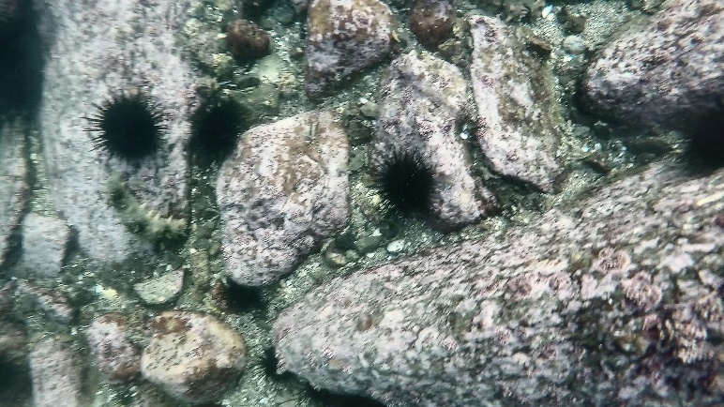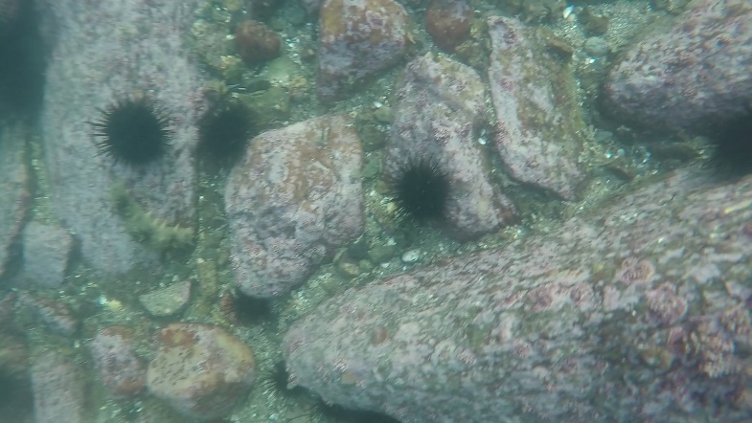

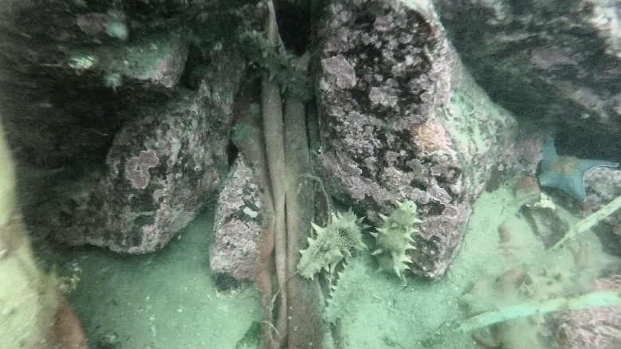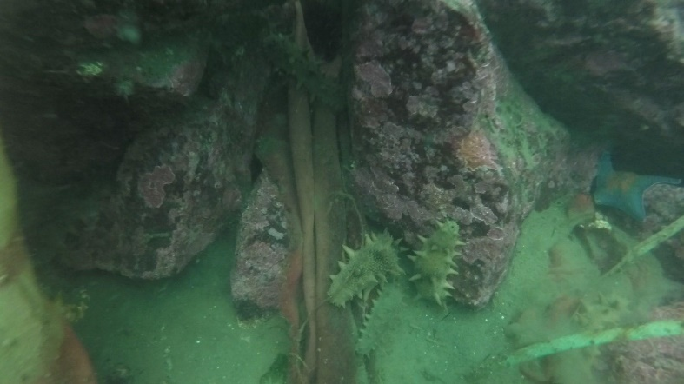

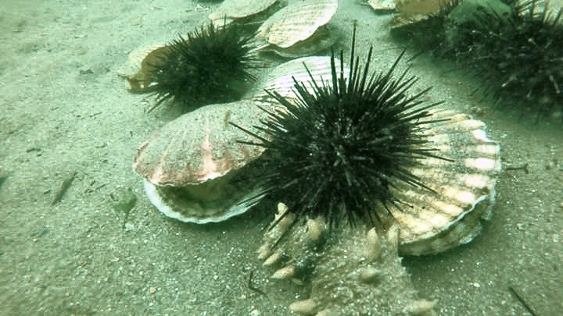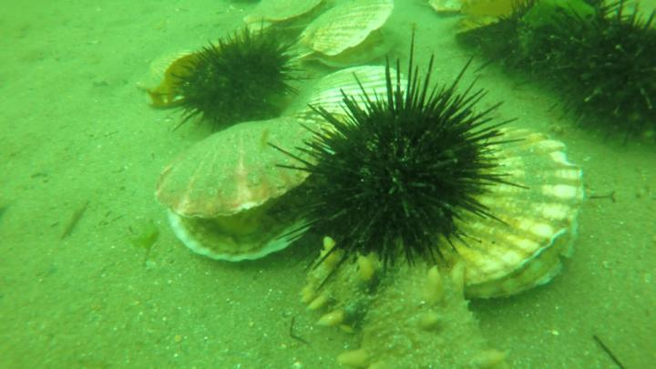

Fig4: Before applying the Image Enhancement Fig5: After applying the Image Enhancement

Technique images Technique images

# 

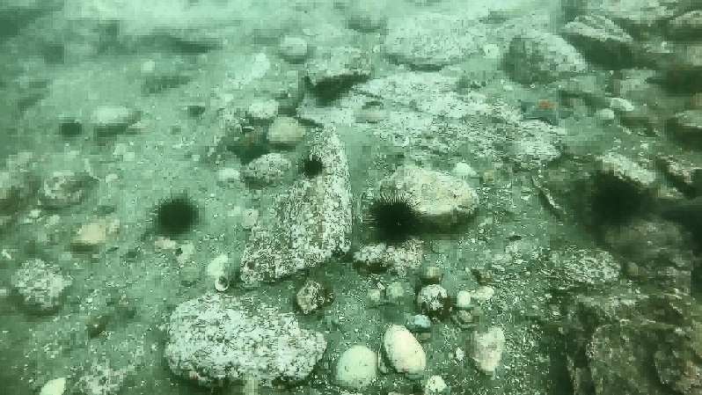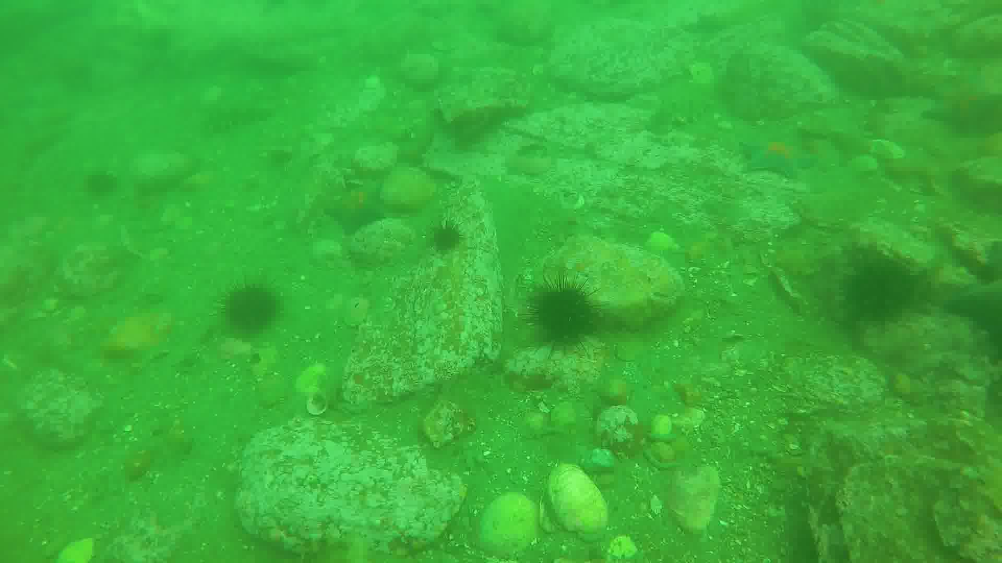

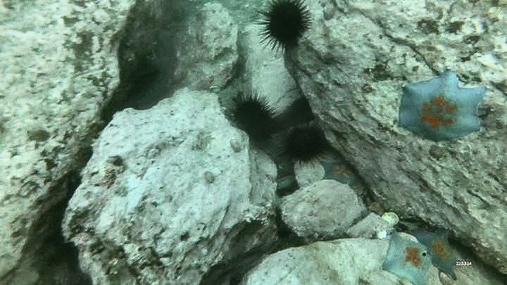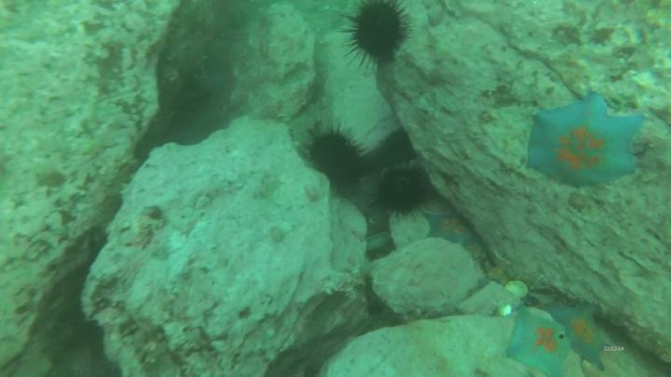

Fig7: After apply image enhancement Technique

Fig6: Before apply image enhancement technique images

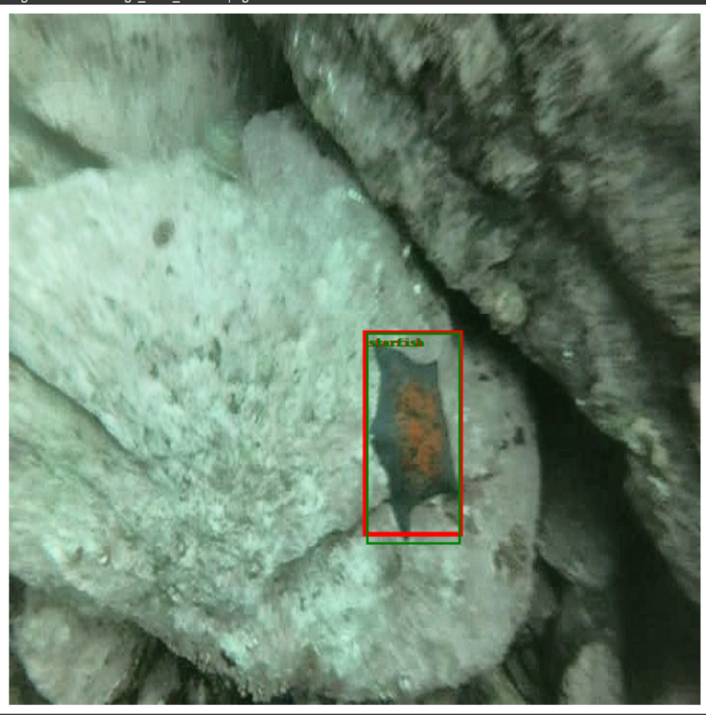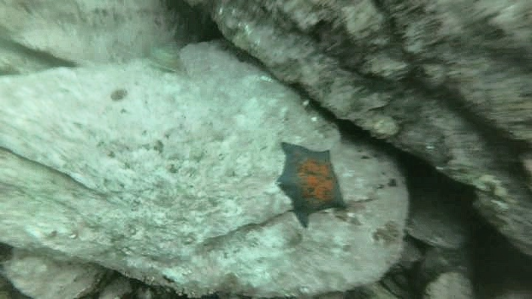

#### 

# 

# 

# 

# 

**Fig 9: Correct detection of species using the proposed method on the URPC dataset. The green bounding box, labeled with the ground truth species, indicates the ground truth. The red bounding box, labeled with the detected species, indicates the detected box.**

**Fig 9: Correct detection of species using the proposed method on the URPC dataset. The green bounding box, labeled with the ground truth species, indicates the ground truth. The red bounding box, labeled with the detected species, indicates the detected box.**

# 

**Fig 9: Correct detection of species using the proposed method on the URPC dataset. The green bounding box, labeled with the ground truth species, indicates the ground truth. The red bounding box, labeled with the detected species, indicates the detected box.**

**Fig8: Before detection of Images**

**6.4 Quantitative Result**

# Table 1: Calculated Average UCIQE And Average Entropy on UTDAC2020 dataset as:

|  |  |  |
| --- | --- | --- |
| Before apply image Enhancement Technique | Average UCIQE 555.3917822495 | Average Entropy 14.350065206 |
| After apply image Enhancement Technique | 9.651096420491 | 7.8700545692 |

Table 2: After Object detection on URPC2020 dataset, the evaluation metrics as:

|  |  |  |  |
| --- | --- | --- | --- |
|  | Mean Average precision(mAP) | Precision | Recall |
| Faster-RCNN with Resnet 50 | 0.7529 | 0.7405 | 0.7657 |
| Yolo v8 | 0.795 | 0.811 | 0.712 |

# Table 3: After Object detection on UTDAC2020 dataset, the evaluation metrics as:

|  |  |  |  |
| --- | --- | --- | --- |
|  | Mean average precision(mAP) | Precision | Recall |
| Faster-RCNN with Resnet 50 | 0.6926 | 0.7312 | 0.7923 |
| YOLO v8 | 0.723 | 0.829 | 0.625 |

# Chapter 7

#### CONCLUSIONS

In this study, we explored the application of Faster R-CNN ResNet-50 and YOLOv8 models for object detection in underwater images, using the UTDAC2020 and URPC2020 datasets. Our primary objective was to enhance the accuracy and efficiency of detecting marine objects under challenging underwater conditions characterized by low visibility and color distortion.

The performance evaluation revealed that both Faster R-CNN ResNet-50 and YOLOv8 models exhibited robust capabilities in detecting various classes of marine objects across different datasets. The Faster R-CNN ResNet-50 model, with its region-based approach and feature pyramid network backbone, demonstrated commendable results with an average Mean Average Precision (mAP) of 0.7226 across the evaluated datasets after 25 epochs of training. However, there remains room for improvement, particularly in achieving a higher mAP score of 0.89 as targeted for more precise object localization and classification.

Comparatively, the YOLOv8 model, known for its real-time processing capabilities and single-stage detection architecture, provided competitive performance metrics, albeit with different trade-offs in accuracy and speed compared to Faster R-CNN. The choice between these models should consider specific application requirements such as real-time processing needs versus accuracy in complex environments.

Throughout our experiments, the preprocessing step of image enhancement proved crucial. Techniques such as white balancing, gamma correction, sharpening, and applying CLAHE and histogram equalization significantly improved image quality and subsequently enhanced model performance. The weighted combination of these methods effectively mitigated the challenges posed by underwater light scattering and color distortion, resulting in clearer and more informative images for the detection models.

Despite the promising results, our study encountered several limitations, including the availability of annotated underwater datasets and computational resources for extensive model training. Future research should focus on expanding the annotated datasets with diverse underwater conditions and species, integrating advanced deep learning architectures, and exploring novel image enhancement techniques tailored specifically for underwater environments.

In conclusion, this study contributes to advancing the field of underwater object detection by demonstrating the efficacy of state-of-the-art deep learning models and image enhancement strategies. By addressing the unique challenges of underwater imaging, we pave the way for applications in marine biology, environmental monitoring, and underwater robotics, ultimately contributing to the sustainable exploration and conservation of our oceans.

**Chapter 8**

# REFERENCES

* [[1]](https://www.sciencedirect.com/science/article/pii/S0952197623019504?via%3Dihub).Haiping Ma , Yajing Zhang, Shengyi Sun, Weijia Zhang, Minrui Fei, Huiyu Zhou (2024) : Weighted multi-error information entropy based you only look once network for underwater object detection.
* [[2]](https://www.sciencedirect.com/science/article/pii/S0957417424001180) Jinxiong Gao, Yonghui Zhang, Xu Geng, Hao Tang, Uzair Aslam Bhatti(2024):PE Transformer for Improving underwater object Detection.
* [[3]](https://www.sciencedirect.com/journal/pattern-recognition) Linthui Dai, Hong Liu, Pinhao Song, Mengyuan Liu(2024) :Patter Recognition- A gated cross domain collaborative network for Under water object detection .
* [[4]](https://www.sciencedirect.com/science/article/pii/S1877050920310784)Sangeetha Mohan , Philomina Simon (2020): Underwater Image Enhancement based on Histogram Manipulatiion and Multiscale Fusion.
* [[5]](https://arxiv.org/abs/1506.01497) Ren, S., He, K., Girshick, R., & Sun, J. (2015). Faster R-CNN: Towards Real-Time Object Detection with Region Proposal Networks. IEEE Transactions on Pattern Analysis and Machine Intelligence, 39(6), 1137-1149.
* [[6]](https://arxiv.org/abs/1506.02640). Joseph Redmon, Santosh Divvala, Ross Girshick, Ali Farhadi (2016). You Only Look Once: Unified, Real-Time Object Detection. Proceedings of the IEEE Conference on Computer Vision and Pattern Recognition (CVPR), 779-788.
* [[7]](https://arxiv.org/abs/2004.08135)Li, J., Chen, Z., Zou, Z., Ma, W., & Chen, C. (2020). The URPC2020 Challenge on Underwater Robot Picking: Methods and Results. Proceedings of the 2020 IEEE International Conference on Robotics and Automation (ICRA), 621-626.